RQ2 How consistent are AI-generated pull-request (PR) descriptions with the actual code changes? - Report

This question examines whether AI models describe their modifications accurately.
Many PR descriptions contain intent keywords (e.g., fix, add tests, refactor), but these keywords may not always match the file-level changes or patch content.

1.Datasets Used
Dataset | Description
pull_request["train"] | Contains AI-generated PR titles and bodies
pr_commit_details["train"] | File-level diffs, including filename, additions, deletions, patch text. Contains AI actual modification.

These datasets allow us to compare claimed intent (from PR descriptions) with actual code-level behavior (from diffs).

2. Methodology
We evaluate consistency through a two-stream comparison approach:

2.1 Extracting Claimed Intent (from pull_request)
From each PR’s title and body, we extract intent keywords:
- fix → bug fixing
- test → adding or improving tests
- refactor → structural code reorganization
- doc → documentation changes
These reflect what the AI claims the PR is doing.

2.2 Extracting Actual Behavior (from pr_commit_details)

File-level signals
- File type:
  - source
  - test
  - Doc
  - unknown

Change-level signals
- Additions： total lines added
- Deletions : total lines removed
- total changes : additions + deletions
- keywords extracted from patch text (fix/add/remove/refactor patterns) : intent clues found inside the actual patch
These represent what actually happened in the PR.
2.3 Consistency Rules
We compare the two signal sets using the following rules:
Rule | Interpretation
fix-doc-mismatch | Description contains “fix” but PR modifies no source code
missing-tests | Description claims “test” but no test files were touched
refactor-mismatch | Description says “refactor” but patch shows mostly additions (feature-like behavior)
aligned | Description matches the diff signals
3. Results
aligned 16812
missing-tests 12676
fix-doc-mismatch 2666
refactor-mismatch 1426

Interpretation
- Aligned PRs are the largest group (~50%), meaning about half of AI descriptions accurately reflect code changes.
- Missing-tests is the most frequent mismatch — AI often claims to add tests but modifies no test files.
- Fix-doc mismatches suggest that AI sometimes labels documentation edits as bug fixes.
- Refactor mismatches indicate confusion between refactoring vs. adding new functionality.
4. Visualizations and Analysis

4.1 Alignment Category Counts (Bar Chart)
Figure: RQ2 — Proportion of Alignment vs Mismatch Categories
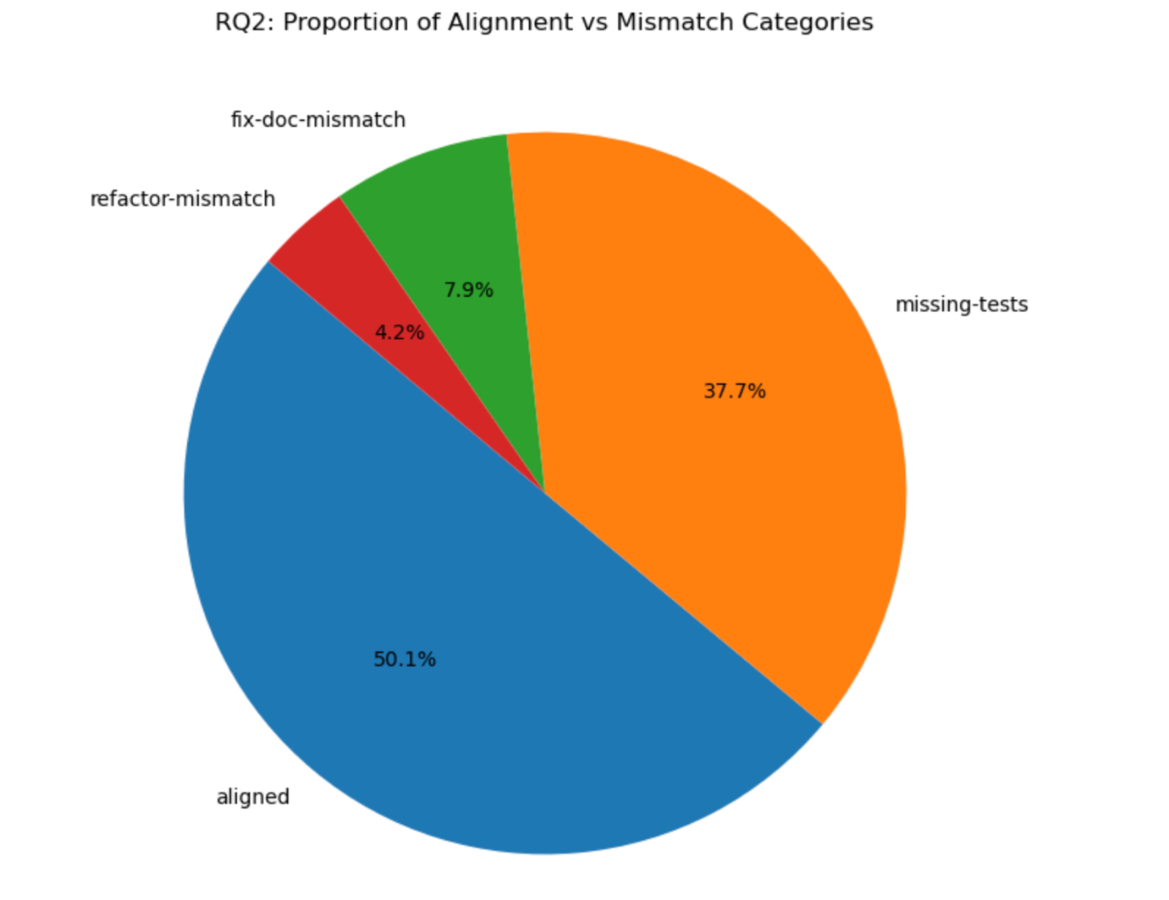

Key Observations
- Nearly half (49.9%) of all PR descriptions do not accurately reflect their code changes.
- Missing-tests accounts for the majority of mismatches.
This confirms that AI models tend to overstate the addition or modification of tests.
- Fix-doc-mismatch reflects that AI occasionally labels documentation edits as bug fixes.
- Refactor-mismatch is less frequent but highlights confusion between refactoring and feature additions.

Interpretation
Approximately 50% of PRs are consistent with their AI-generated descriptions, while the remaining 50% exhibit some form of mismatch. The most common breakdown comes from incorrect test-related claims.

4.2 Magnitude of Code Changes by Category (Boxplot)

Figure: Distribution of Code Changes by Alignment Result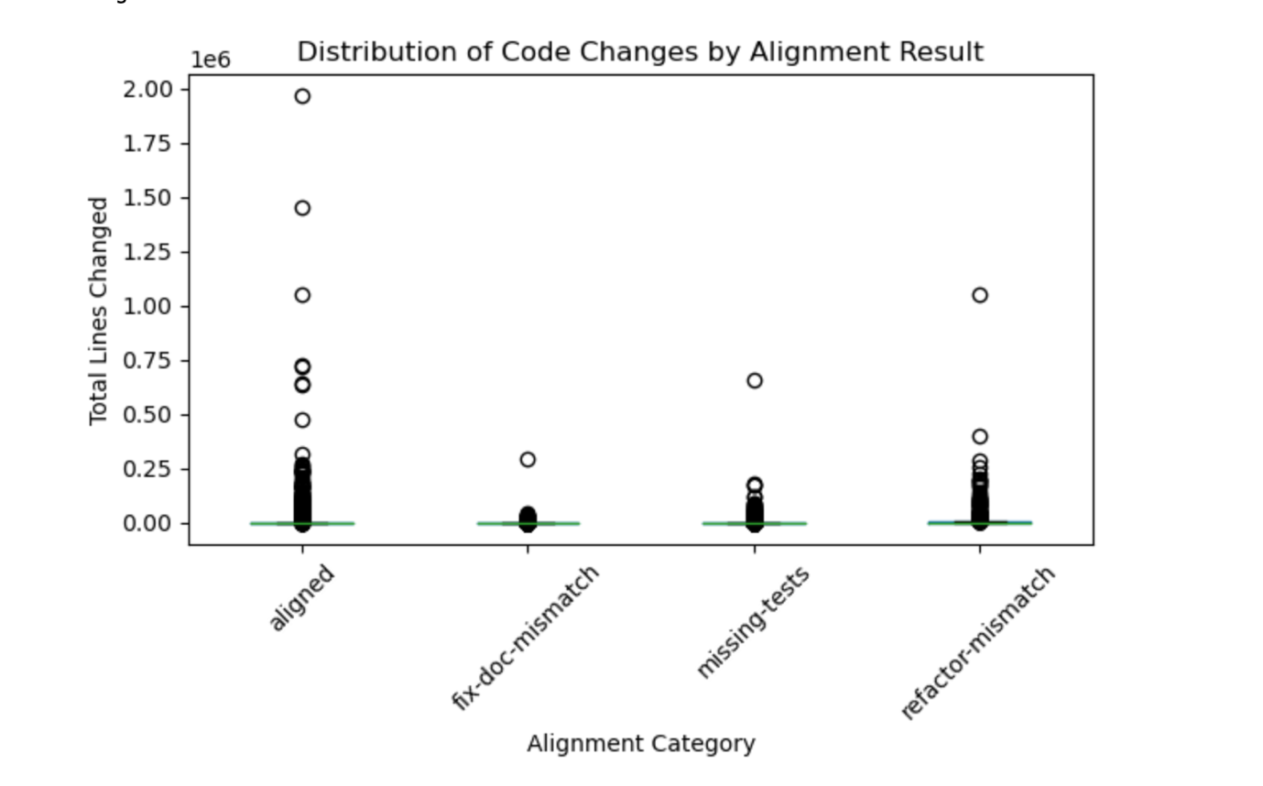

Key Observations
- All categories exhibit extreme outliers, with some PRs changing hundreds of thousands of lines — likely due to file renames, vendor code, or bulk operations.
- Aligned PRs show a relatively wide spread, suggesting they include both small and large-scale changes.
- Fix-doc-mismatch PRs generally have very small modifications, supporting the idea that many of these PRs primarily touch documentation rather than code.
- Missing-tests shows moderate change sizes, but with no correlation to test-file modification, further supporting the inconsistency between description and behavior.
- Refactor-mismatch shows similar variance to aligned PRs, suggesting that large additions are common even when the description claims refactoring.

Interpretation
The magnitude of changes does not directly correlate with alignment categories, but the boxplot highlights systematic behavioral patterns:
- Documentation-only PRs create small change sets → often mislabeled as bug fixes.
- Large feature-like changes are sometimes inaccurately described as refactoring.

4.3 File Types Modified by Category (Stacked Bar Chart)
Figure: File Types Touched by Alignment Category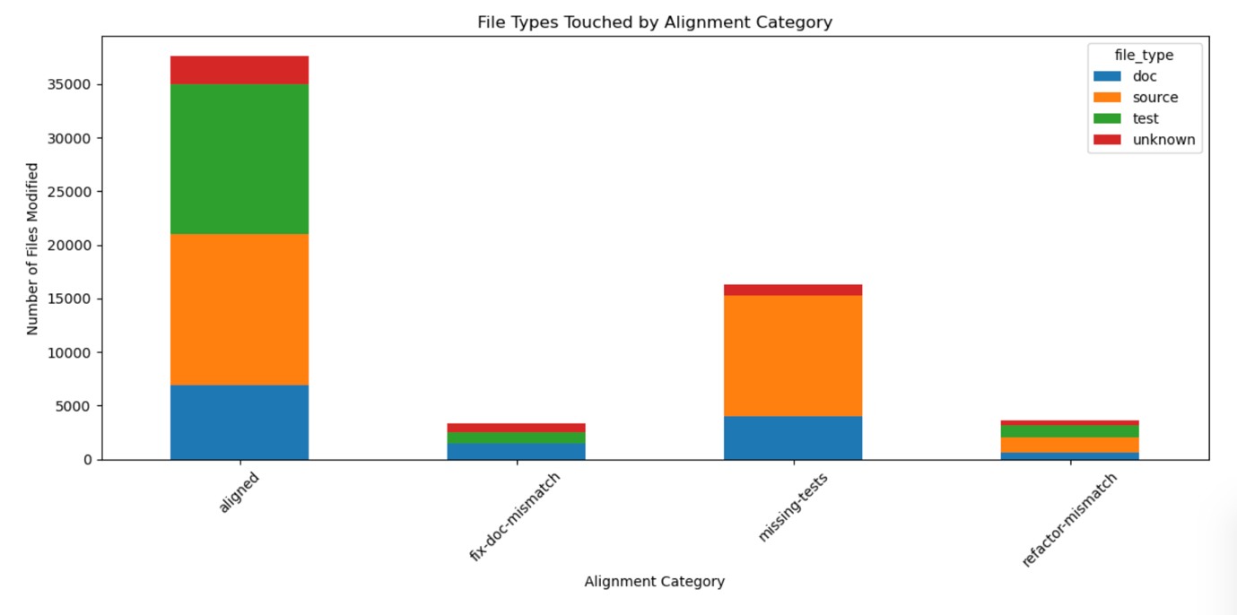

Key Observations
- Aligned PRs modify a healthy mix of source, test, and doc files.
They include ~7k docs, ~14k source, and ~14k test files.
- Missing-tests PRs show zero meaningful modification to test files, despite claiming test-related changes. These PRs heavily modify source files instead.
- Fix-doc-mismatch PRs modify mostly documentation, with almost no source code involved — precisely the mismatch definition.
- Refactor-mismatch PRs modify mostly source files but often involve heavy additions rather than the expected deletion-focused pattern of refactoring.

Interpretation
File-type analysis provides strong evidence for the mismatch categories:
- When AI claims “add tests,” real test files are not touched.
- When AI claims to “fix bugs,” it often modifies docs instead of source code.
- When AI claims “refactor,” it often adds new code, contradicting refactoring patterns.

5. Summary of Findings
Across all four visualizations, a consistent story emerges:

1. AI PR descriptions are accurate only ~50% of the time.
The remaining half contain meaningful inconsistencies.

2. The most common mismatch (37.7%) is “missing-tests.”
AI descriptions frequently claim tests were added, when the diffs show none.

3. Documentation edits are often mislabeled as bug fixes.
~8% of PRs labeled as fixes do not modify any source code.

4. Refactoring claims are sometimes incorrect.
Many so-called “refactors” behave like feature additions (large positive code additions).

5. File-type analysis strongly validates the mismatch rules.
The patterns in the stacked bar chart match the logic of each category precisely.

6. Conclusion
The visual evidence clearly demonstrates that AI-generated PR descriptions are not consistently reliable. While half of them correctly match the actual code changes:
- Claims about tests are often exaggerated or incorrect.
- Claims about bug fixes often correspond to documentation-only changes.
- Claims about refactoring frequently mask feature-like behavior.

Overall implication:
AI-generated PR descriptions should be treated as assistance, not authoritative summaries. Human reviewers or automated diff-checking logic remain essential for ensuring correctness in real-world software workflows.

